

**Project Report**

Department : CSE

Project name : Online Educational System

Course Name : Tools and Technologies for Internet Programming

Course Code : CSE - 3532

**Submitted To :** Sara Karim

Adjunct Lecturer, Dept. of CSE, IIUC

**Submitted By :**

Name & ID : 1. Maryam Tahira – C231519

2. Nishat Tasnim – C231521

3. Mallika Barua – C231529

Semester : 5th

Section : 5DF

Date of submission : 09.06.2025

**Project Title :** Online Educational System.

**Team Members :** 1. Maryam Tahira

2. Nishat Tasnim

3. Mallika Barua

**Introduction :** In recent years, online education has emerged as a powerful alternative to traditional classroom learning, offering flexibility, accessibility, and a wide range of learning opportunities to people around the world. With the increasing demand for digital learning platforms, educational websites have become essential tools for students, professionals, and lifelong learners.

This project, titled "Online Educational Platform Website", is developed with the aim of providing a simple yet effective platform for learners to explore available courses and enroll according to their interests.

**Objective :** The objective of this project is to create a user-friendly, responsive, and secure online educational platform where users can browse, learn about, and enroll in different courses. The platform aims to serve as a bridge between learners and professional instructors by offering accessible and well-structured learning content.

**Tools & Technologies Used:**

|  |  |
| --- | --- |
| **Category** | **Tools / Technologies** |
| Frontend | HTML5, CSS3, Bootstrap 5 |
| Backend | PHP |
| Database | MySQL (via XAMPP) |
| Server | Apache (via XAMPP) |
| IDE | Visual Studio Code |

**Project Description:**

This web-based application is a fully functional educational platform that allows users to explore and enroll in a variety of online courses. The website features multiple sections such as:

1.Home Page

2.About Us

3.Instructor Info

4.Course Enrollment

5.Login System

The platform provides a simple user interface with responsive design, built using Bootstrap, ensuring a smooth experience across devices. The backend was built using PHP, with data managed and stored in a MySQL database using XAMPP as the local server.

**Frontend Design:**

The frontend of the website was developed using:

◑HTML for page structure

◑CSS for custom styling

◑Bootstrap for layout and responsiveness(for final work used also PHP)

Features include:

◑Responsive navigation bar

◑Course cards displaying title, price, duration, and instructor info

◑Enroll buttons, Enrollment option.

◑Testimonials and footer section

**Backend & Database Integration:**

The backend was developed using PHP, which handles:

⇨User authentication (login system)

⇨Course enrollment form submission

⇨Data insertion and retrieval from the database

⇨Payment method selection

Database operations were done using MySQL, with a structured schema that includes tables such as:

⇨users

⇨courses enrolments

XAMPP was used to run both the Apache server and MySQL locally for development and testing purposes.

**Key Functionalities:**

1.User Login System: Users must log in to enroll in a course.

2. Course : Courses are listed with titles, prices, and images.

3. Enrollment Form: Logged-in users can enroll by selecting a payment method (bKash, Nagad, Visa, MasterCard).

4. Admin Access (Future Scope): Admins can manage courses and view enrollments.

5. Data Security: Passwords are hashed before storage (using password_hash()).

**Achievements:**

➤Built a responsive and interactive front-end

➤Successfully integrated MySQL database using PHP and XAMPP

➤Implemented secure user login and enrollment system

➤Supported multiple payment method choices

**Challenges Faced:**

⇨Handling user authentication and session management

⇨Ensuring secure database communication

⇨Creating a smooth user experience across all screen sizes

**Flowchart**

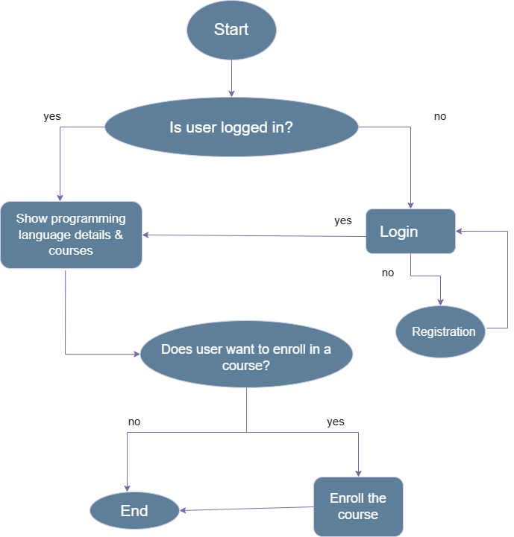

**Screenshots:**

**Front before login:**

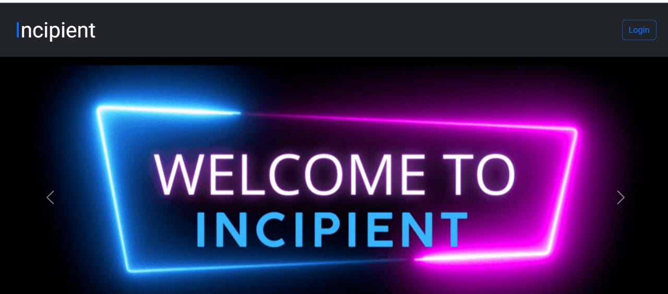

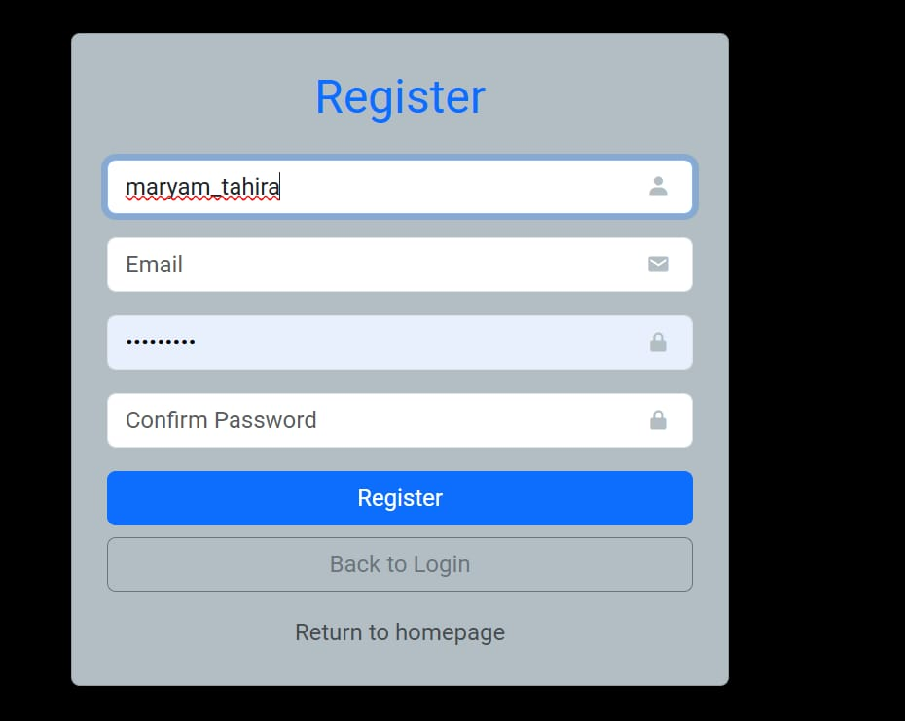 **Registration Form:**

**In case user not found or still not registered:**

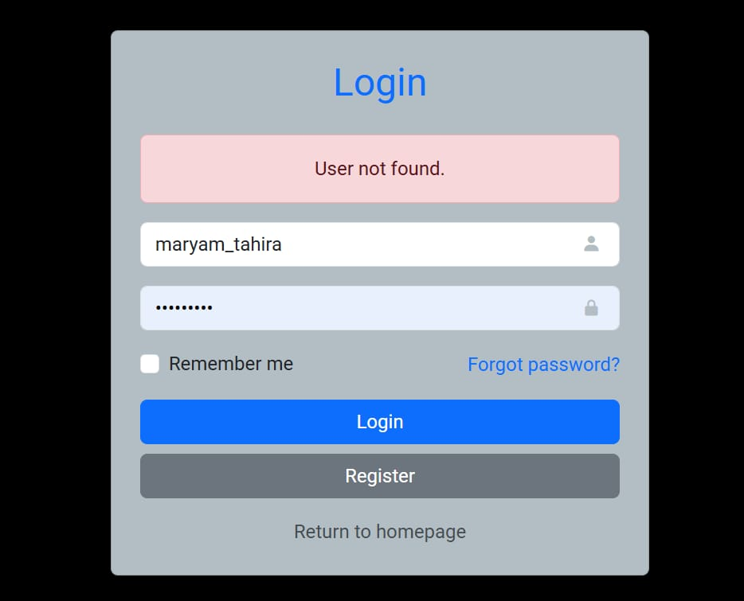

**Incipient database to insert registration data,course and enrolment data:**

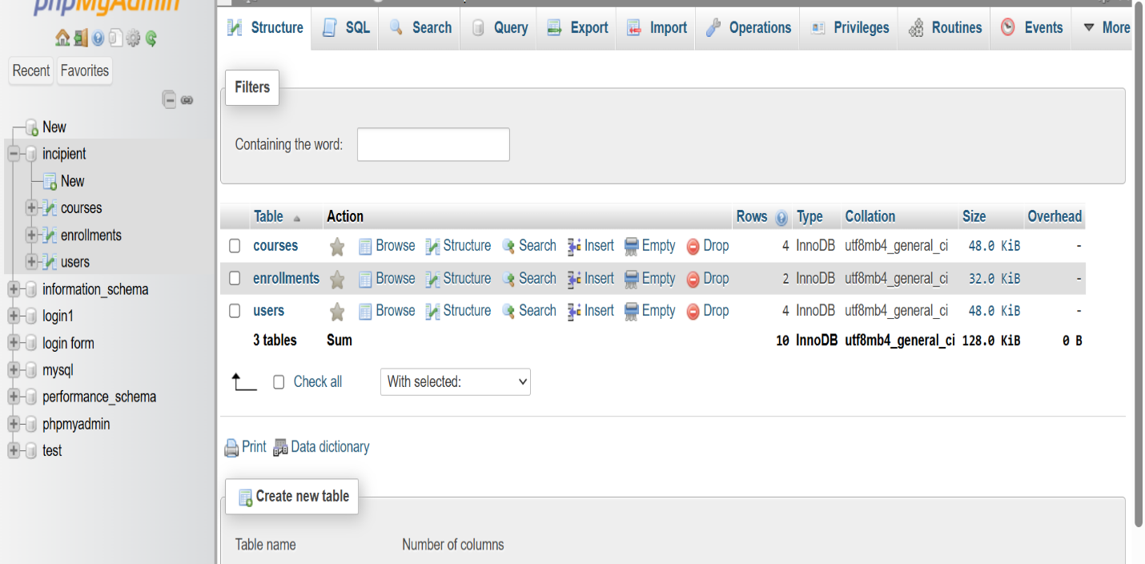

**Courses list on database:**

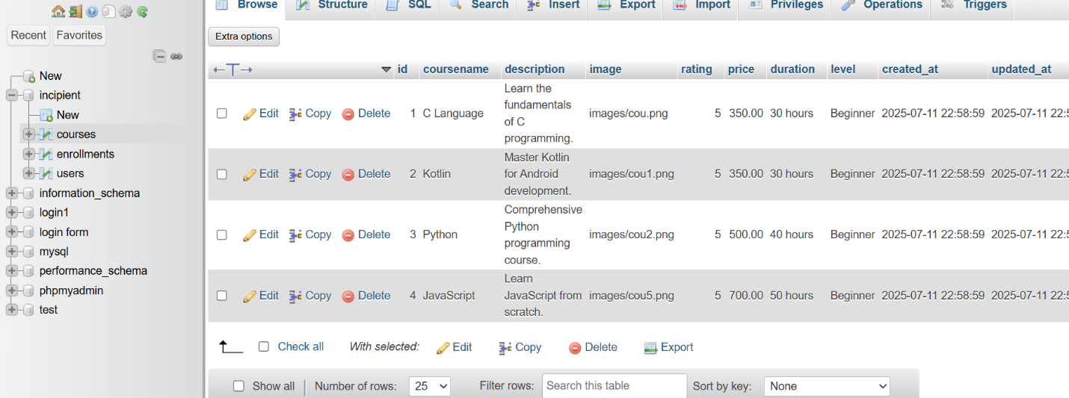

**Data base of who sign in on this website:**

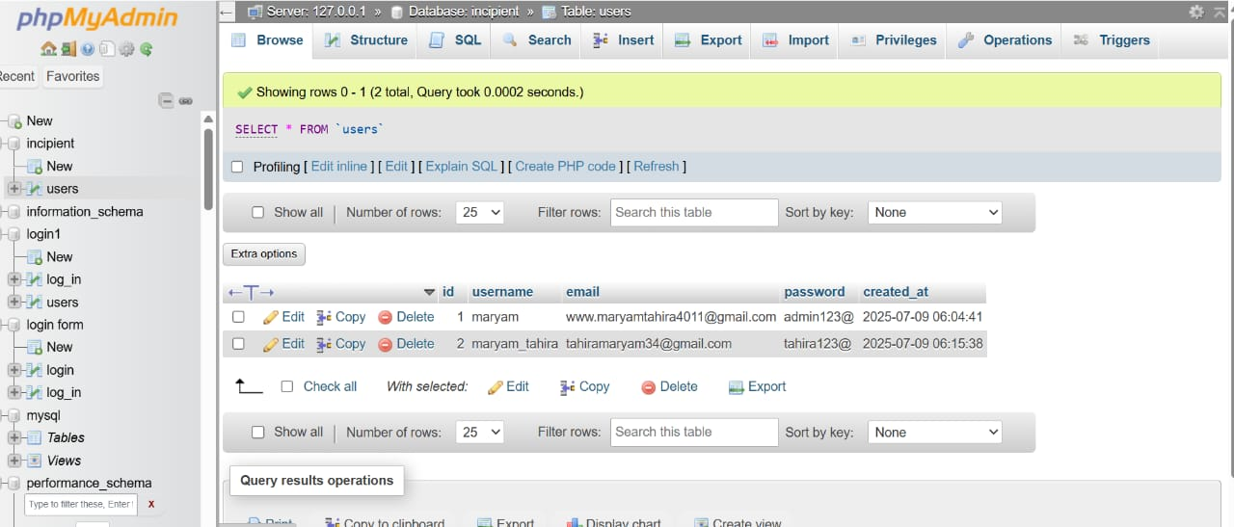

**To enroll in any course you have click the card and confirm registration :**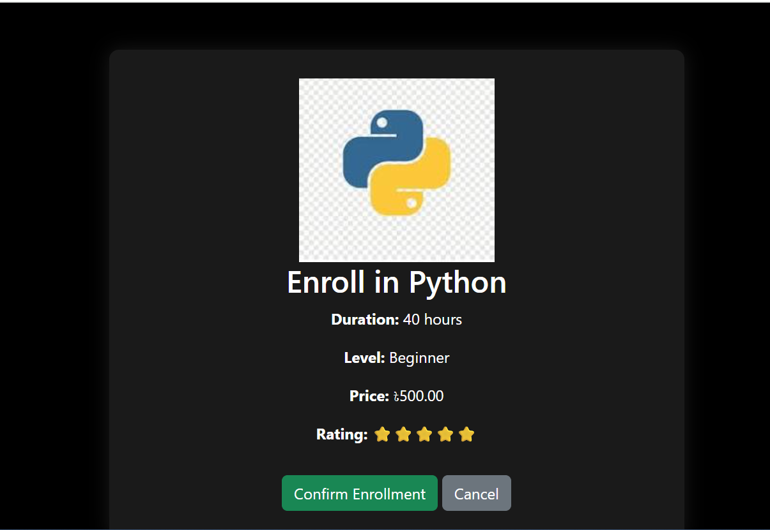

**After Completing enrollment:**



**Course enrolled list:**

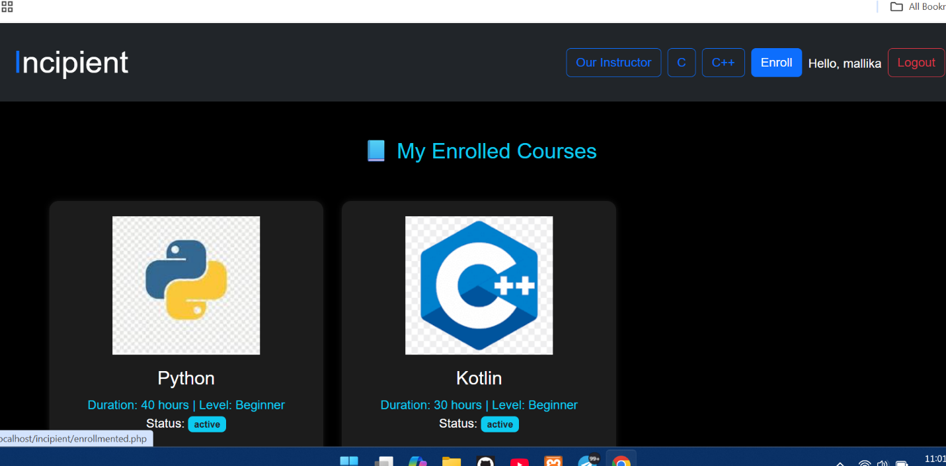

**In case you haven’t enrolled any course yet:**

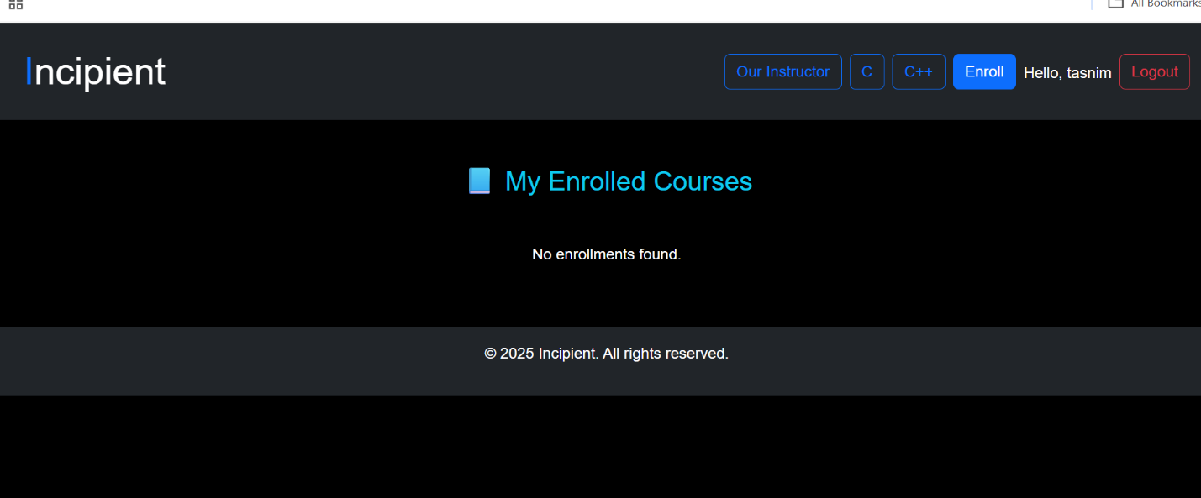

**Enrolled list on database(using user id and course id):** 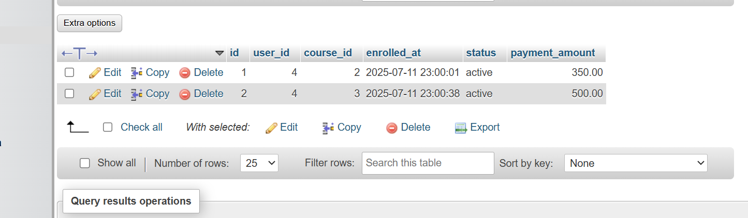

**All instructor Linkdin profile:**

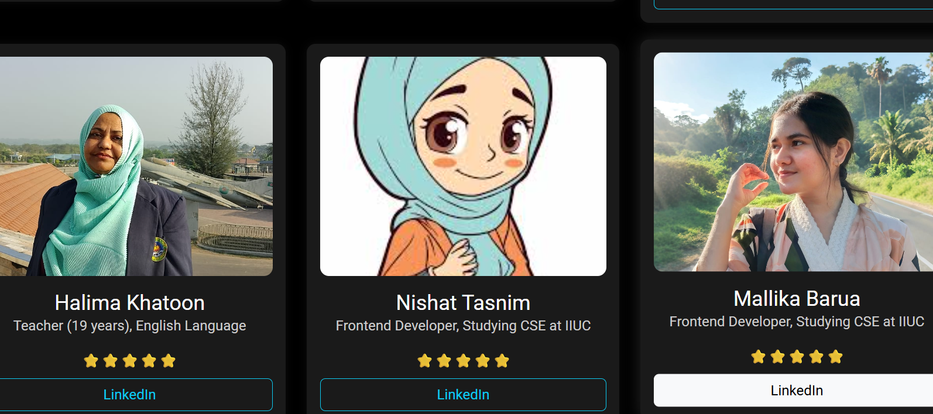

**Conclusion:**

This project demonstrates the implementation of a complete web-based educational platform using basic web technologies. It provides users with a clean, responsive interface and allows them to interact with course content and enrollments effectively. It serves as a foundation for developing more advanced e-learning solutions in the future.